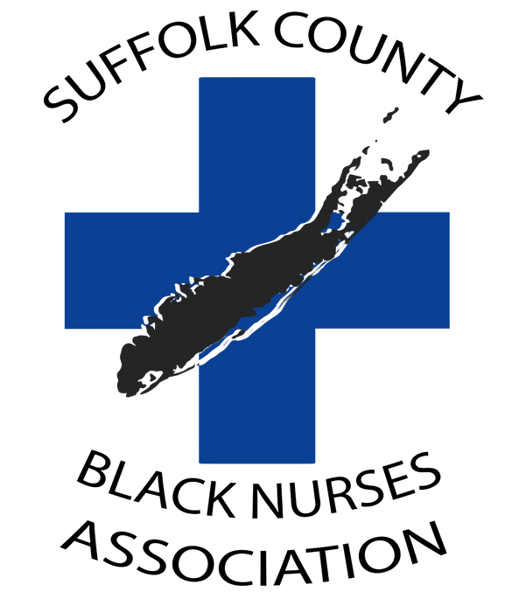

Suffolk County Black Nurses Association
2026 Scholarship Application

Please Type or Print clearly in Ink

Name: ___________________________________________________________________________________
First Middle Last

Daytime Phone#: __________________________ Email: ___________________________________________

Current Address: ___________________________________________________________________________

City _______________________ State ________________ Zip Code________________________

Place of Employment: _______________________________________________________________________

Are you a SCBNA Student Member: Yes ❑ No ❑ If Yes, Year joined: __________________________________

SCBNA Membership Number: _________________________________________________________________

Do you currently hold a Nursing License? Yes ❑ No❑

If Yes: License Number: _______________________________________ State: ______________________

Current School of Nursing Enrollment:
(School listed below is where your official transcript should be mailed from)

Name__________________________________________________________________________
Address: _______________________________________________________________________
City: ___________________ State: ___________________ Zip Code: _______________________
Dean/Director: ________________________ School Phone No. ( ) ____________________
Email Address_____________________________________________________
Student ID #: _____________________________________________________
Bursar/Financial Office #: ____________________________________________
Type of Nursing Degree Program – Choose One: Associate ❑ Bachelors ❑ Masters ❑ Doctorate ❑
Expected Graduation Date (Month/Year): ________________________ Advisor: ________________
Extracurricular/Community Activities (List): _____________________________________________________________________________________
_____________________________________________________________________________________
Personal Statement Essay Instructions (REQUIRED)
Each applicant must submit a personal statement essay of 250-500 words responding to the following questions:
1. How will your role as a registered nurse impact the nursing profession?
2. Where do you see yourself 5 years from now, and how will you facilitate this achievement?
3. Which life experiences have shaped you into who you are today?
4. What challenges have you overcome to achieve your education?

• I hereby affirm that all the information provided is complete and true. Any false statement(s) will make my application null and void.
• I consent to publish photograph in SCBNA publications and/or SCBNA website.

Signature: ________________________________________ Date: ______________________________

[You may attach a continuation sheet if necessary]
General Instructions – Follow all instructions for preparation and submission of your application

The following is required for submission
1. A completed application form.
2. Two letters of recommendation. One professional from applicant's school of nursing or employer and one personal from a nurse in the area or politician or religious leader.
3. A copy of your current resume or CV (5 pages max)
4. Personal statement essay (500-words maximum)
5. Proof of acceptance to nursing program
6. Proof of enrollment the Fall 2026 semester (Bursar bill)
7. Proof of employment, residency of Suffolk County or attending school in Suffolk County

Application submission Instructions
Applications and supporting materials will ONLY be accepted electronically
Assemble the following materials and save as one pdf file (Only pdf files will be accepted) with this file name
FORMAT: (Your Last name – Scholarship Application), Ex – Smith-Scholarship Application
1. Completed application form
2. Two letters of recommendation
3. Resume or CV
4. Personal statement
5. Proof of acceptance to nursing program
6. Proof of enrollment the Fall 2026 semester (Bursar bill)
7. Proof of employment, residency of Suffolk County or attending school in Suffolk County
Submit the pdf file via email using the same file name in the Subject to: suffolkcountybna@hotmail.com
Submit your high-resolution head shot photo to the same email address.
Submission of your official school Transcript (Must be received by August 14th, 2026)
Have your school mail your official transcript directly to:

SUFFOLK COUNTY BLACK NURSES ASSOCIATION
Attn: SCBNA Scholarship Committee
P.O. Box 416
Brentwood, New York 11717
RECEIPT OF APPLICATION AND ALL REQUIRED INFORMATION AS INDICATED
ABOVE MUST BE RECEIVED VIA EMAIL BY CLOSE OF
BUSINESS AT 5:00 PM (EST) ON OR BEFORE August 14th, 2026.

QUESTIONS: Please direct all questions to the SCBNA Scholarship Committee via email at: suffolkcountybna@hotmail.com

